C++ Program Sheet

Topic: Operators & Conditional Statements
Total Questions: 15

Section A: Operators (Q1–Q7)

Q.1 Write a C++ program to input two integers and perform all arithmetic operations.

#include <iostream>
using namespace std;

int main()
{
int a, b;

// Input
cout << "\nEnter a : ";
cin >> a;

cout << "Enter b : ";
cin >> b;

cout << "\n--- Arithmetic Operations ---\n\n";

// Addition
cout << a << " + " << b << " = " << (a + b) << endl;

// Subtraction
cout << a << " - " << b << " = " << (a - b) << endl;

// Multiplication
cout << a << " * " << b << " = " << (a * b) << endl;

// Division
cout << a << " / " << b << " = " << (a / b) << endl;
// Reminder
cout << a << " % " << b << " = " << (a % b) << endl;

return 0;
}

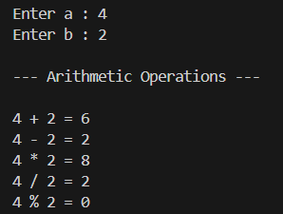

Q.2 Write a program to demonstrate relational operators between two numbers.

#include <iostream>
using namespace std;

int main()
{
int a, b;

cout << "\nEnter a number: ";
cin >> a;

cout << "Enter b number: ";
cin >> b;

cout << "\n--- Relational Operators ---\n";

cout << a << " == " << b << " : " << (a == b) << endl;
cout << a << " != " << b << " : " << (a != b) << endl;
cout << a << " > " << b << " : " << (a > b) << endl;
cout << a << " < " << b << " : " << (a < b) << endl;
cout << a << " >= " << b << " : " << (a >= b) << endl;
cout << a << " <= " << b << " : " << (a <= b) << endl;

return 0;
}

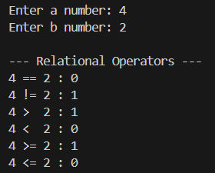

Q.3 Write a program to check voting eligibility using logical operators.

#include <iostream>
using namespace std;

int main()
{
int age;

// Input
cout << "Enter your age: ";
cin >> age;

// Condition using logical AND (&&)
if (age >= 0 && age < 18)
{
cout << "You are NOT eligible to vote." << endl;
}
else if (age < 0)
{
cout << "You are NOT eligible to vote." << endl;
}
else
{
cout << "You are eligible to vote.";
}
return 0;
}

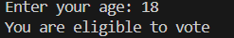

Q.4 Write a program demonstrating assignment operators (=, +=, -=, *=, /=).

#include <iostream>
using namespace std;

int main()
{
int a, b, temp;

cout << "\nEnter value of a: ";
cin >> a;

cout << "Enter value of b: ";
cin >> b;

// = operator
temp = a;
temp = b;
cout << "\nAfter a = b, a = " << temp << endl;

// += operator
temp = a;
temp += b;
cout << "After a += b, a = " << temp << endl;

// -= operator
temp = a;
temp -= b;
cout << "After a -= b, a = " << temp << endl;

// *= operator
temp = a;
temp *= b;
cout << "After a *= b, a = " << temp << endl;

// /= operator
temp = a;
temp /= b;
cout << "After a /= b, a = " << temp << endl;

return 0;
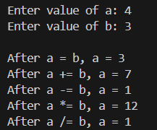
}

Q.5 Write a program to demonstrate pre and post increment/decrement operators.

#include <iostream>
using namespace std;

int main()
{
int a = 10;

cout << "Initial value = 10\n\n";

// Pre Increment
cout << "Pre-increment (++a): " << ++a << endl;
cout << "Value of a after operation: " << a << endl
<< endl;

// Post Increment
cout << "Post-increment (a++): " << a++ << endl;
cout << "Value of a after operation: " << a << endl
<< endl;

// Pre Decrement
cout << "Pre-decrement (--a): " << --a << endl;
cout << "Value of a after operation: " << a << endl
<< endl;

// Post Decrement
cout << "Post-decrement (a--): " << a-- << endl;
cout << "Value of a after operation: " << a << endl;

return 0;
}

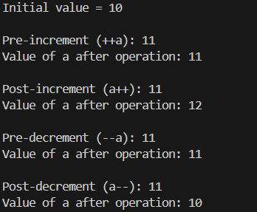

Q.6 Write a program to perform bitwise AND, OR, and XOR operations.

#include <iostream>
using namespace std;

int main()
{
int a, b;

cout << "\nEnter first number: ";
cin >> a;

cout << "Enter second number: ";
cin >> b;

cout << "\n--- Bitwise Operations ---\n\n";

// Bitwise AND
cout << a << " & " << b << " = " << (a & b) << endl;

// Bitwise OR
cout << a << " | " << b << " = " << (a | b) << endl;

// Bitwise XOR
cout << a << " ^ " << b << " = " << (a ^ b) << endl;

return 0;
}

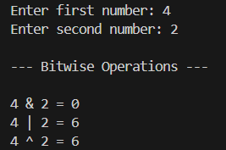

Q.7 Write a program to find the largest of two numbers using the ternary operator.

#include <iostream>
using namespace std;

int main()
{
int a, b, largest;

cout << "\nEnter first number: ";
cin >> a;

cout << "Enter second number: ";
cin >> b;

// Ternary operator
largest = (a > b) ? a : b;

cout << "Largest number is: " << largest << endl;

return 0;
}

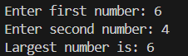

Section B: Conditional Statements (Q8–Q15)

Q.8 Write a program to check whether a number is positive.

#include <iostream>
using namespace std;

int main()
{
int num;
cout << "Enter a number: ";
cin >> num;

if (num > 0)
cout << "Number is Positive";
else
cout << "Not Positive";

return 0;
}

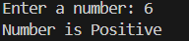

Q.9 Write a program to check whether a number is even or odd.

#include <iostream>
using namespace std;

int main()
{
int num;
cout << "Enter a number: ";
cin >> num;

if (num % 2 == 0)
cout << "Even Number";
else
cout << "Odd Number";

return 0;
}

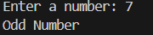

Q.10 Write a program to display grade based on marks using if-else ladder.

#include <iostream>
using namespace std;

int main()
{
int marks;
cout << "Enter marks: ";
cin >> marks;

if (marks >= 90)
cout << "Grade A";
else if (marks >= 75)
cout << "Grade B";
else if (marks >= 60)
cout << "Grade C";
else if (marks >= 40)
cout << "Grade D";
else
cout << "Fail";

return 0;
}

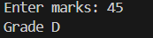

Q.11 Write a program using nested if to check positive/negative and even/odd.

#include <iostream>
using namespace std;

int main()
{
int num;
cout << "Enter a number: ";
cin >> num;

if (num >= 0)
{
cout << "Positive ";
if (num % 2 == 0)
cout << "and Even";
else
cout << "and Odd";
}
else
{
cout << "Negative ";
if (num % 2 == 0)
cout << "and Even";
else
cout << "and Odd";
}

return 0;
}

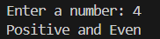

Q.12 Write a program to create a simple calculator using switch case.

#include <iostream>
using namespace std;

int main()
{
int a, b;
char op;

cout << "\nEnter a : ";
cin >> a;
cout << "Enter operator (+,-,*,/): ";
cin >> op;
cout << "Enter b : ";
cin >> b;

switch (op)
{
case '+':
cout << "Result = " << a + b;
break;
case '-':
cout << "Result = " << a - b;
break;
case '*':
cout << "Result = " << a * b;
break;
case '/':
if (b != 0)
cout << "Result = " << a / b;
else
cout << "Division by zero not allowed";
break;
default:
cout << "Invalid Operator";
}

return 0;
}

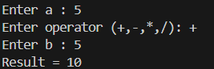

Q.13 Write a program to find the largest of three numbers.

#include <iostream>
using namespace std;

int main()
{
int a, b, c;
cout << "\nEnter a : ";
cin >> a;
cout << "Enter b: ";
cin >> b;
cout << "Enter c: ";
cin >> c;

if (a >= b && a >= c)
cout << "Largest = " << a;
else if (b >= a && b >= c)
cout << "Largest = " << b;
else
cout << "Largest = " << c;

return 0;
}

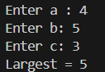

Q.14 Write a program to check whether a given year is a leap year.

#include <iostream>
using namespace std;

int main()
{
int year;
cout << "\nEnter year: ";
cin >> year;

if ((year % 4 == 0 && year % 100 != 0) || (year % 400 == 0))
cout << "Leap Year";
else
cout << "Not a Leap Year";

return 0;
}



Q.15 Write a program to calculate electricity bill based on unit slabs.

#include <iostream>
using namespace std;

int main()
{
int units;
float bill;

cout << "\nEnter electricity units: ";
cin >> units;

if (units <= 100)
bill = units * 5;
else if (units <= 200)
bill = (100 * 5) + (units - 100) * 7;
else
bill = (100 * 5) + (100 * 7) + (units - 200) * 10;

cout << "Total Bill = Rs. " << bill;

return 0;
}

